
Our school: together and apart
Reflections for ‘school’ at home: Happy-Sad-Happy
A note for parents and carers:
At school, your child will be used to taking part in collective worship every day (they might call it ‘assembly’). This is not the kind of worship that some of you might be have been part of in a religious building. In church schools this collective worship is planned to be:
- Inclusive: something for children and teachers, of all faiths or of none to be able to join in with
- Inspirational: a time in the day to think about the big questions in our lives; an occasion that supports the school community’s spiritual development, creates an opportunity to gather around and reflect on a common theme and ‘feeds’ their inner being;
- Invitational: in school, children and teachers are invited to pray, think, or reflect, it is the child’s or teacher’s choice how they respond.

At this time, many children will be missing the familiar routines of school. One way in which we can help to keep that sense of normality is by offering these resources to schools to share with their school community at home. Please be clear: these ideas are for you to use, adapt, or not use at all. You choose!

We plan to produce these resources for the weeks that schools are ‘at home’ and would love to know if there’s anything that your school community at home would appreciate. You can find our contact details on the Diocesan website.
Jane Whittington & Rachel Boxer

Theme: Easter: happy or sad?
- There is a story to share together if you would like to, on page 3. The Easter story is a difficult story, with many contrasting emotions and questions that are hard to answer, so don’t be worried if children ask questions you can’t answer. Teachers are very used to saying ‘I don’t know, but let’s think about these things together.’! When you look at the Easter story, it doesn’t hide the emotions expressed by people in the story: ‘negative’ emotions such as despair, anger, fear, confusion and disappointment as well as hope, joy, surprise and love. For Christians, this is one of the things about this story that brings such comfort – that it’s OK to be bewildered by our emotions – so make use of this opportunity to share how you’re feeling together.
- Look at the picture of an Easter garden. Many Christian families might make one of these for their home or church. Talk about the things that you can see in the garden – and why you think each element might be included.

Things to talk about together:
- Talk together about the things that make you sad, and things that make you happy. If it helps, you could talk specifically about how this time doing school at home might be both sad, and happy.
- Are there other times when you can be happy one minute, and sad the next?
- Make ‘faces’ at each other to show different emotions e.g. sad, happy, confused, frightened, angry, surprised etc. The Easter story has some sad parts and some happy parts – and other parts that connect with these different emotions. If you choose to use the story together, then spend some more time afterwards talking about the emotions that different people in the story expressed.

Things to do together:
- Using circles of paper or paper plates, make double-sided ‘faces’ expressing these emotions: sad, happy, confused, frightened, angry, surprised. If you’d prefer, there are links to ‘emoji’ style pictures on the next page. Then share the story on page 3, using the paper plate faces you’ve made or by making a ‘face’ yourselves to match the emotions in the story. Which do you think is the most important feeling in the story?
- Make Easter cards to send to family members or people who are feeling lonely. Write them a message that will cheer them up.
- Make an Easter garden together. Simple instructions can be found here. If you have an outside space, you might like to do this outside in a corner of your garden, using natural resources. Or you could use indoor construction materials such as Lego or recycled materials. Talk about the ‘sad’ and ‘happy’ parts of the garden. Or if you prefer, you could make an Easter picture with natural materials found outside such as leaves, stones & sticks. There are some really lovely ideas to get you started here.
- Do some easy baking together to make Easter nests using the recipe here.
- Hide Easter eggs around your garden or house for children to find – or set children the challenge of creating an Easter egg hunt for you, with written clues for you to work out!

Things to reflect on or pray about together:

- Cut a large flower shape from paper for each person in your house. Think about the emotion(s) you’re feeling right now and write it or draw a face expressing it in the middle of the flower. Then fold in the petals. Float the flowers on a bowl of water and watch the petals open up. As they unfold, try to let go of how you are feeling or give those emotions to God and ask him to help you.
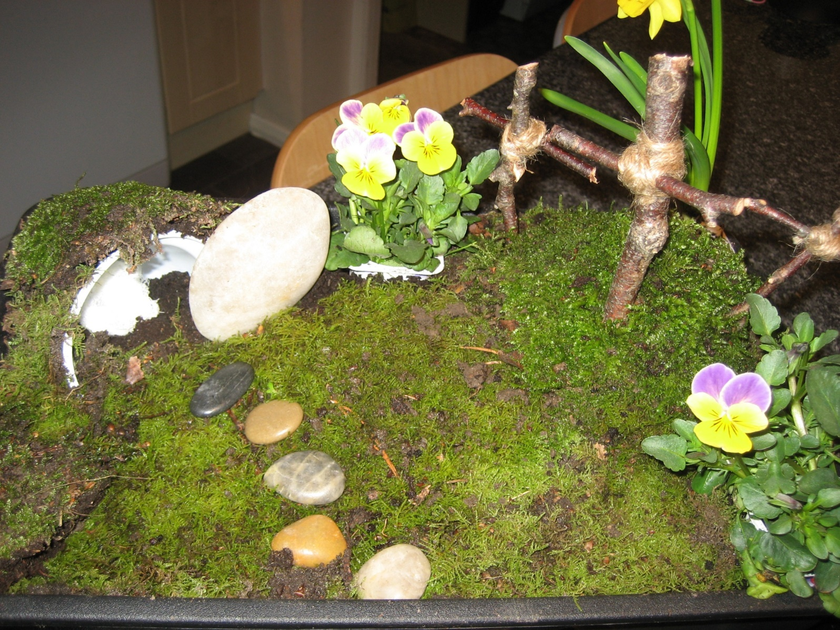

Emotion | Emoji link
Happy | https://pixabay.com/illustrations/emoticon-smile-emoji-happy-2120024/
Sad | https://pixabay.com/illustrations/emoji-facebook-sad-smilies-emotion-4717567/
Angry | https://pixabay.com/illustrations/emoticon-emoji-angry-swearing-1669804/
Confused | https://pixabay.com/illustrations/emoji-emotions-face-wondering-2744064/
Frightened | https://pixabay.com/illustrations/graphic-smiley-emoji-emoticon-3850583/
Surprised | https://pixabay.com/vectors/graphic-smiley-emoticon-surprised-3643247/

The happy-sad-happy story
When Jesus rode into Jerusalem on a donkey, the crowds were very happy to see him. They cheered and waved palm branches. ‘Jesus the king is here!’ they shouted happily. ‘Hosanna in the highest!’ Jesus’ friends, the disciples, were also happy because Jesus had come to save them – and at last he would be king over the Romans!

A few days later, Jesus gathered with his friends for a special meal called the Passover. The friends were all happy to be together. As they sat down at the table, Jesus knelt down and washed their feet – like a servant! Now the disciples weren’t happy – they were angry and confused. Jesus was their teacher – not their servant! Next, as Jesus took the bread and gave it to them, he said that it would remind them of his broken body, and the wine, his blood. The friends were even more confused. What did Jesus mean by all this?
In the garden after the meal, soldiers came to arrest Jesus because he had made the leaders very angry by saying that he was God, and so they took Jesus away to be punished. Now the friends were all frightened, and rather than risk being caught as well, they all ran away. Now Jesus was sad and alone.

The next day, Jesus was put on a cross with two thieves, one each side. The women who were Jesus’ friends stood by, sadder than they’d ever been before. And when Jesus died, the sky went dark and the earth trembled. It was as if the whole world was sad too. Jesus was taken down from the cross and put into a tomb with a big stone rolled across the entrance, and Roman soldiers to guard it.

Early on Sunday morning, Mary and the other women went to the tomb, sadder than they’d ever been before, but when they got there, they found that the soldiers had run away, frightened – and the big stone had been rolled to one side. Now they weren’t sure what to feel! Sad? Confused? Frightened? Frightened!!! – an angel was standing by the tomb! ‘Don’t be frightened!’ he said. ‘Jesus is not here – he is ALIVE!!’
And so they ran, with joy in their hearts – to share the happiest news of all, that Jesus was alive.

